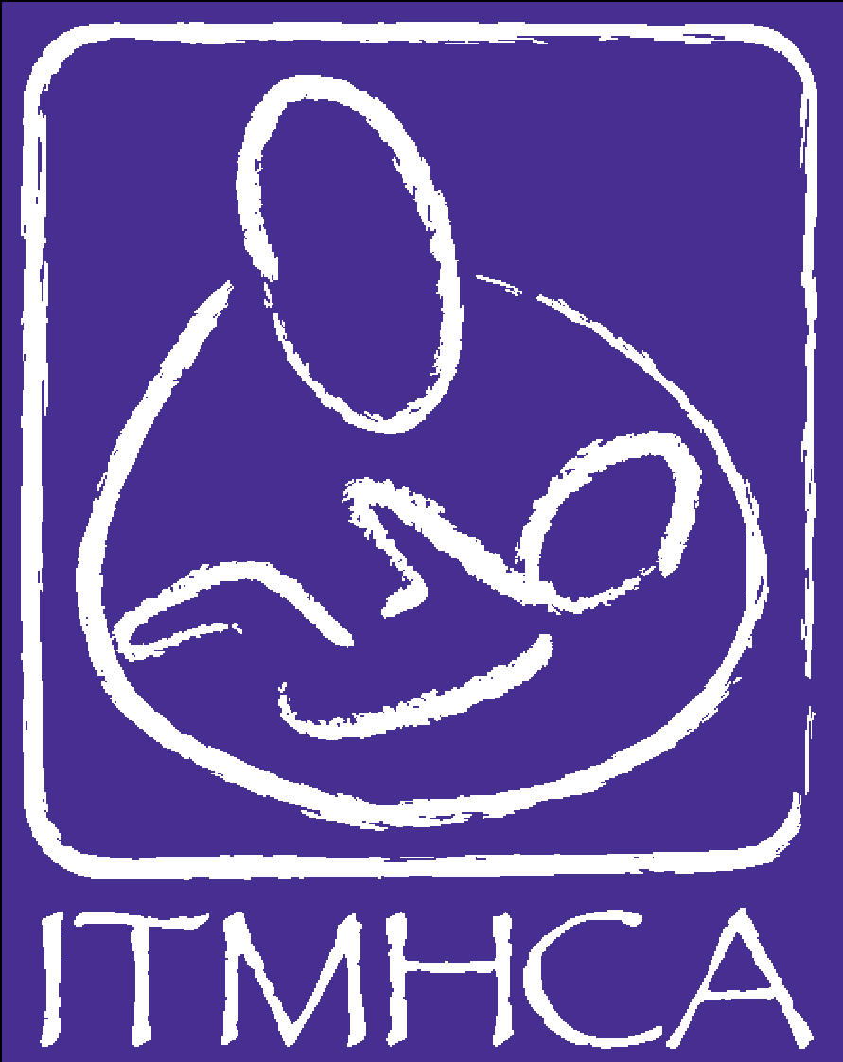
INFANT-TODDLER MENTAL
HEALTH COALITION OF
ARIZONA

What to know About the Infant Mental Health Endorsement® Exam

Congratulations on taking the next step and considering sitting for the Infant Mental Health Endorsement® (IMH-E®) exam! This is an exciting next step in your infant-early childhood mental health professional development. Our hope is to provide with you as much support to be successful on the exam as is possible. This includes a thorough 2-tier application review of your Endorsement® application, with detailed feedback, and access to preparation resources. The intent of this resource is to prepare you for what will be expected within the exam.

The exam has two parts and both are based on the Competency Guidelines®. The Competency Guidelines® is a critical reference in preparing for the exam. The competencies are divided into domains, which are referred to below. If you no longer have the copy of the Competency Guidelines® that you received when you started the Endorsement® process, please contact your association’s Endorsement Coordinator and inquire about how to receive another copy.

This document should be used in conjunction with the Endorsement® Examination Preparation Resource List.

Part One: Multiple Choice

The multiple-choice portion of the exam is the same for all exam respondents: Infant Mental Health Specialist (IMHS), Infant Mental Health Mentor-Clinical (IMHM-C), Infant Mental Health Mentor-Policy (IMHM-P), and Infant Mental Health Mentor-Research/Faculty (IMHM-R/F).

Exam respondents have 90-minutes to answer 60 multiple-choice questions. Exam respondents indicate their answers on a paper answer sheet, with a pencil, upon reading questions from a printed document. You may wish to bring your own pencil although one will also be provided for you. Eighty percent or better is required to pass (no more than 12 incorrect answers).

- The multiple-choice section is meant to measure what is known and is derived primarily from the knowledge and skill areas found under the Theoretical Foundations and Direct Service Skills domains of the Competency Guidelines®. These domains address your IMH knowledge specific to work with pregnant women, infants/toddlers (0-36 months) and their families
- Within the Theoretical Foundations domain, there will be a greater emphasis on the areas of pregnancy and early parenthood; infant/young child development & behavior; attachment, separation, trauma, grief, & loss; and disorders of infancy/early childhood
- Within the Direct Service Skills domain, there will be a greater emphasis on the areas of screening & assessment, parent-infant/very young child relationship-based therapies & practices, and reflective supervision
- The multiple-choice questions will have a greater emphasis on direct service, however, there will be some questions related to reflective supervision/consultation, policy, ethical practice, service delivery systems and research
- Knowledge gained through course work, specialized in-service training, and self-study will be most useful in this section of the exam

Part Two: Vignettes/Scenarios
The vignettes/scenarios portion of the exam is different for exam respondents depending on category of Endorsement®. Endorsement® exam responses may differ from how one may respond to a clinical or licensing exam. The following information outlines what is expected for each category of Endorsement®.

Infant Mental Health Specialist (IMHS)

Exam respondents for the IMHS exam have 90-minutes to respond to two of three direct service vignettes which must be answered from the perspective of an IMH specialist/practitioner. Both responses must be complete, and both must receive passing scores. Said another way, if a core concept is described in one response, respondents cannot assume that the concept is “covered.” Critical IMH principles should be apparent in responses to both vignettes.
While all of the knowledge and skill areas of the Competency Guidelines® are important, the ones under the Reflection, Thinking, and Working with Others domains are especially important to qualitative section for IMHS respondents. Knowledge and skills gained through reflective supervision/consultation (RS/C) about direct service experiences with pregnant women, infants/toddlers (0-36 months) and their families will be most useful in this section of the exam
The vignettes are available as a hard copy and on a flash drive as a Word document. The flash drive is inserted into a computer and responses are typed directly into the Word document, saved, and printed. Prior to the start of the 90-minutes, you have 15-minutes to read the hard copy of the vignettes and take notes on the hard copy. You may wish to bring a highlighter for this.

- This section of the exam is meant to measure how your knowledge of IMH principles and concepts is applied into practice and for you to demonstrate a reflective, relationship-based approach specific to work with infants/toddlers (0-36 months) and their families. It is not meant to measure fidelity to a particular model or treatment modality. It is meant to capture the “how you are” part of IMH practice, as being just as important as “what you do.” This requires responses from an IMH perspective that includes the application of parent-infant/young child relationship-based therapies and practices
- Responses should explore past and present issues related to attachment, separation, trauma and unresolved losses as they affect the development, behavior and care of the infant/young child
- Responses should consider all of the relationships presented in the vignettes, including consideration of parallel process
- Responses should include use of self
- Responses should indicate attention to and exploration of the role of race and culture in the lives of all people in the vignettes
    - Responses should indicate the capacity to articulate a reasonable number of hypotheses
    - Responses should attend to and explore issues surrounding safety
    - You will be asked to respond to the same four questions after each of the direct service vignettes. The questions will ask you to share your responses about the possible experiences of the people in vignettes, in addition to your own understanding, reactions, questions, and thoughts. It will be important for you to keep in mind what you don’t know yet

Infant Mental Health Mentor-Clinical (IMHM-C)

Exam respondents for the IMHM-C exam have 90-minutes to respond to one of two direct service vignettes which must be answered from the perspective of an IMH specialist/practitioner and one vignette about the provision of RS/C which must be answered from the perspective of a reflective supervisor/consultant. Both responses must be complete, and both must receive passing scores. Said another way, if a core concept is described in one response, respondents cannot assume that the concept is “covered.” Critical IMH principles should be apparent in responses to both vignettes. What follows is what is anticipated for the vignette response about the provision of RS/C. To review what is expected for response on the direct service vignette, see above within the Infant Mental Health Specialist section.
While all of the knowledge and skill areas of the Competency Guidelines® are important, the ones under the Reflection, Thinking, and Working with Others domains are especially important to the qualitative section for IMHM-C exam respondents. Knowledge and skills gained through RS/C about direct service experiences with pregnant women, infants/toddlers (0-36 months) and their families and about the RS/C provided to others will be most useful in this section of the exam.
The vignettes are available as a hard copy and on a flash drive as a Word document. The flash drive is inserted into a computer and responses are typed directly into the Word document, saved, and printed. Prior to the start of the 90-minutes, you will have 15-minutes to read the hard copy of the vignettes and take notes on the hard copy. You may wish to bring a highlighter for this.

- This section of the exam is meant to measure how your knowledge of IMH principles and concepts is applied into practice (“ways of being”) and for you to demonstrate a reflective, relationship-based approach specific to work with infants/toddlers (0-36 months), their families, and the reflective supervision/consultation you provide to others. It is not meant to measure fidelity to a particular model or treatment modality. It is meant to capture the “how you are” part of IMH practice, as being just as important as “what you do.” This requires responses from an IMH perspective that includes the application of parent-infant/young child relationship-based therapies and practices as well as the Best Practice Guidelines for Reflective Supervision/Consultation
- Responses should consider all of the relationships presented in the vignettes, including consideration of parallel process
- Responses should include use of self
- Responses should indicate attention to and exploration of the role of race and culture in the lives of all people in the vignettes
    - Responses should indicate the capacity to articulate a reasonable number of hypotheses
    - You will be asked to respond to four questions after each of the vignettes. The questions will vary slightly for the direct service and reflective supervision vignettes. The questions will ask you to share your responses about the possible experiences of the people in vignettes, in addition to your own understanding, reactions, questions, and thoughts. It will be important for you to keep in mind what you don’t know yet

Infant Mental Health Mentor – Policy (IMHM-P)
Exam respondents for the IMHM-P exam will have 90-minutes to respond to one scenario.

The scenario is available as a hard copy and on a flash drive as a Word document. The flash drive is inserted into a computer and responses are typed directly into the Word document, saved, and printed. Prior to the start of the 90-minutes, you will have 15-minutes to read the hard copy of the scenario and take notes on the hard copy. You may wish to bring a highlighter for this.

- This section of the exam is meant to measure your knowledge of policy priorities related to IMH principles and practices and how you apply this knowledge into your own program development/administration and/or advocacy efforts
- Respondents are expected to identify policy issues relevant to IMH and demonstrate ability to develop appropriate strategies to address them
- While all of the knowledge and skill areas are important, those under the Administration domain will be the primary focus of the qualitative section for IMHM-P exam respondents
- The review of the response will take into consideration the relevance of the approaches and/or methods offered to address a problem, as well as the respondent’s attention to IMH concerns

Infant Mental Health Mentor – Research/Faculty (IMHM-R/F)
Exam respondents for the IMHM-R/F exam will have 90-minutes to respond to one of two scenarios related to teaching or research.
The scenarios are available as a hard copy and on a flash drive as a Word document. The flash drive is inserted into a computer and responses are typed directly into the Word document, saved, and printed. Prior to the start of the 90-minutes, you will have 15-minutes to read the hard copy of the scenarios and take notes on the hard copy. You may wish to bring a highlighter for this.

- This section of the exam is meant to measure your knowledge of research related to IMH principles and practices and how you apply this knowledge into your own research/evaluation OR teaching in higher education settings
- One scenario will be related to the role of teaching in the field of IMH and includes prompts to which you will respond, should you choose this scenario
- One scenario will be related to conducting research within the field of IMH and includes prompts to which you will respond, should you choose this scenario
- While all of the knowledge and skill areas are important, the ones under the Research & Evaluation domain will be the primary focus of the qualitative section for IMHM-R/F exam respondents
- Respondents should expect to offer up-to-date citations and evidence specific to IMH for the approaches used in their responses
- The review of the response will take into consideration the relevance of the research cited as well as the respondent’s attention to IMH concerns

Preparation: Please do not feel as though you need to wait to begin studying for the exam until you receive the results of your application review. We encourage you to begin studying as soon as you decide that you hope to sit for an upcoming exam.

Self-Reflection & Study: Refer back to the Getting Started Guide (hard copy), the Competencies tab of your EASy application, and/or feedback received about your application review to identify areas where you may find additional study to be useful. In addition to the selection of readings from the Endorsement® Exam Prep Resource List, you are encouraged to review the notes, slides, and materials from the specialized in-service trainings in which you have participated.
When considering the trainings you have attended, it is important to note that training series that occur over time and include opportunities for reflective discussion offer better preparation for the qualitative section of the exam than “one and done” training sessions.

One’s disciplinary background may also provide guidance. For example, applicants who come from a background that emphasizes development may find they require more studying related to mental health competencies like attachment, trauma, grief and loss, mental and behavioral disorders in adults, supportive counseling, intervention/treatment planning, etc. While those from a mental health background may need more studying in areas such as infant/very young child development & behavior, developmental guidance, typically developing attachment, etc.

You are encouraged to find study partners in your geographic area to support you during your studies and reflection on your work.

Guidance from provider(s) of RS/C for IMHS and IMHM-C: You are encouraged to engage your provider of RS/C in conversations about your professional journey, capacity for reflection, and understanding of parallel process all in relation to readiness for the exam. The reference rating form can be used to solicit feedback related to knowledge and skill areas of the Competency Guidelines®. PDF versions of reference rating items can be found at https://www.allianceaimh.org/endorsement-requirements-guidelines. If gaps in knowledge or skill areas are identified, you will want to study those areas first. If your provider of RS/C expresses reservations related to your capacity to apply IMH principles into practice, you are encouraged to continue with RS/C and on-going assessment of the skills in the domains of Reflection, Thinking, and Working with Others.

Accommodations for the Examination: If you would like an accommodation for either part of the examination, you must submit a written request to the Endorsement Coordinator no later than 21 days (3 weeks) before your examination date. The request must detail the kind of accommodation being requested, as well as documentation of the need for an accommodation (i.e., an assessment from a professional). The Coordinator will respond to the request at least 10 days before the examination date. We are committed to meeting the needs of all members but may not be able to grant every accommodation request. The Endorsement Coordinator will work closely with you to develop a plan that offers a reasonable accommodation without compromising the integrity of the examination, your identity, or the identity of the Reviewers. In these instances, it may be necessary and appropriate to offer the exam on a different date in order to accommodate you. If the Endorsement Coordinator is unsure of the appropriate accommodation for a special circumstance, they may contact the Alliance for the Advancement of Infant Mental Health Quality Assurance Director

If your primary language is something other than English and you request an accommodation, you can have up to an additional 60 minutes for each section of the exam, i.e., a total of 2 ½ hours for Part One and a total of 2 ½ hours for Part Two. In addition, you may take a dictionary into the examination to assist in translation (e.g., a Spanish to English dictionary)

