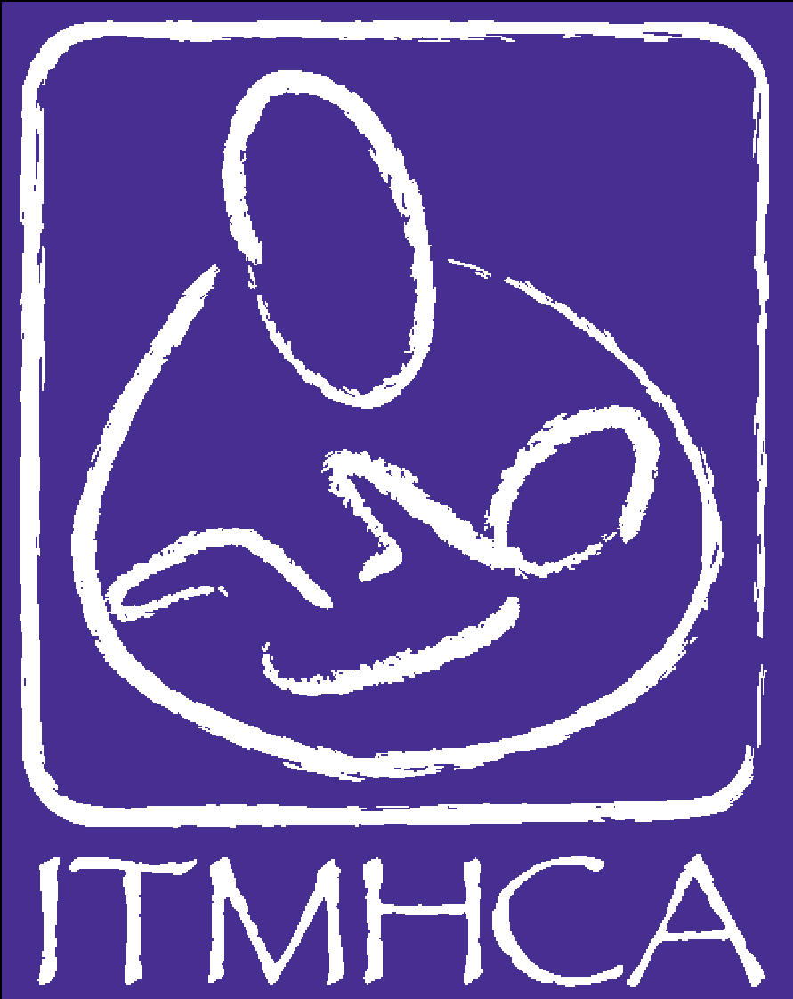
INFANT-TODDLER MENTAL
HEALTH COALITION OF
ARIZONA

Getting Started Form

This form is an optional (but strongly recommended) self-study to help assess your experiences and determine what additional specialized training might be necessary to meet the competencies and earn ITMHCA Endorsement®.

- Read the Competency Guidelines®, paying special attention to the specifics of the requirements for the Endorsement® for which you are applying
- Review your resume/vita, a copy (unofficial is ok) of your transcripts, and gather your in-service training records
- Look at what you have done, using the self-study grid below, and ask yourself if you have had a college/university course, an in-service training, a work experience or a reflective supervision/consultation (RS/C) experience that has contributed to your knowledge or skill in a particular area. For now, place a check mark in the appropriate box (or write short notes about the experience). These check marks will help you identify the competency areas once you begin work in your EASy Application. Consider where your strengths lie and what you need to do to “fill in the gaps” to develop greater competency as an Infant Family Associate (IFA), Infant Family Specialist (IFS), Infant Mental Health Specialist (IMHS) or Infant Mental Health Mentor (IMHM)
- Keep in mind that during a formal application review, a minimum of one trained Application Reviewer will comprehensively examine your materials and come to agreement about whether or not you have met the requirements and the competencies. All of the knowledge and skill areas are required (as specified for each category of Endorsement®), but application reviewers will be paying close attention to those listed under Theoretical Foundations and Direct Service Skills. In general, when considering whether or not a knowledge/skill area has been “met,” the most weight is given to college courses, then to intensive or series in-services, then to shorter in-services, then conferences, then reference ratings, then work experience
- Identify gaps i.e., competency areas where you feel you have not yet had enough specialized education or in-service training
- Find in-service training opportunities to help you fill in any identified gaps in the knowledge/skill areas. Information about relevant training opportunities can be found at https://www.itmhca.org/training.php.

Theoretical Foundations | Education | Work | In-service training(s)
pregnancy and early parenthood
(IFA, IFS, IMHS, IMHM)
infant/young child development and behavior
(IFA, IFS, IMHS, IMHM)
infant/young child & family-centered practice
(IFA, IFS, IMHS, IMHM)
relationship-based, therapeutic practice
(IFA, IFS, IMHS, IMHM)
family relationships & dynamics
(IFA, IFS, IMHS, IMHM)
attachment, separation, trauma & loss
(IFA, IFS, IMHS, IMHM)
psychotherapeutic & behavioral theories of change
(IMHS & IMHM)
disorders of infancy/early childhood
(IFS, IMHS, IMHM)
mental & behavioral disorders-adults
(IMHS & IMHM)
cultural competence
(IFA, IFS, IMHS, IMHM)
adult learning theory & practice
(IMHM)
statistics
(IMHM)
research & evaluation
(IMHM)

Law, Regulation & Policy | Education | Work | In-service training(s)
ethical practice
(IFA, IFS, IMHS, IMHM)
government, law & regulation
(IFA, IFS, IMHS, IMHM)
agency policy
(IFA, IFS, IMHS, IMHM)

Systems Expertise | Education | Work | In-service training(s)
service delivery systems
(IFA, IFS, IMHS, IMHM)
community resources
(IFA, IFS, IMHS, IMHM)

Direct Service Skills | Education | Work | In-service training(s)
observation & listening
(IFA, IFS, IMHS, IMHM)
screening & assessment
(IFA, IFS, IMHS, IMHM)
responding with empathy
(IFA, IFS, IMHS, IMHM)
intervention/treatment planning
(IMHS & IMHM)
developmental guidance
(IMHS & IMHM)
supportive counseling
(IMHS & IMHM)
parent-infant/very young child relationship-based therapies & practices
(IMHS & IMHM)
advocacy
(IFA, IFS, IMHS, IMHM)
life skills
(IFA, IFS, IMHS, IMHM)
safety
(IFA, IFS, IMHS, IMHM)
reflective clinical supervision
(IMHM - clinical)

Working with Others | Education | Work | In-service training(s) | RS/C
building & maintaining relationships
(IFA, IFS, IMHS, IMHM)
supporting others
(IFA, IFS, IMHS, IMHM)
mentoring
(IFS, IMHS, IMHM)
coaching & mentoring
(IMHM)
collaborating
(IFA, IFS, IMHS, IMHM)
resolving conflict
(IFA, IFS, IMHS, IMHM)
crisis management
(IMHM)
empathy & compassion
(IFA, IFS, IMHS, IMHM)
consulting
(IMHM)

Communicating | Education | Work | In-service training(s) | RS/C
listening
(IFA, IFS, IMHS, IMHM)
speaking
(IFA, IFS, IMHS, IMHM)
writing
(IFA, IFS, IMHS, IMHM)
group process
(IMHM)

Thinking | Education | Work | In-service training(s) | RS/C
analyzing information
(IFA, IFS, IMHS, IMHM)
solving problems
(IFA, IFS, IMHS, IMHM)
exercising sound judgment
(IFA, IFS, IMHS, IMHM)
maintaining perspective
(IFA, IFS, IMHS, IMHM)
planning & organizing
(IFA, IFS, IMHS, IMHM)

Reflection | Education | Work | In-service training(s) | RS/C
contemplation
(IFA, IFS, IMHS, IMHM)
self awareness
(IFA, IFS, IMHS, IMHM)
curiosity
(IFA, IFS, IMHS, IMHM)
professional/personal development
(IFA, IFS, IMHS, IMHM)
emotional response
(IFA, IFS, IMHS, IMHM)
parallel process
(IMHS & IMHM)

Infant Mental Health Mentor only:

Leading People | Education | Work | In-service training(s)
motivating
(IMHM)
advocacy
(IMHM)
developing talent
(IMHM)

Administration | Education | Work | In-service training(s)
program management
(IMHM - policy)
program development
(IMHM - policy)
program evaluation
(IMHM - policy)
program funding
(IMHM - policy)

Research & Evaluation | Education | Work | In-service training(s)
study of infant relationships & attachment
(IMHM – research/faculty)
study of infant development & behavior
(IMHM – research/faculty)
study of families
(IMHM – research/faculty)

